****The Nation****al Police Wildlife Crime Officers** **Training Course**

** The only accredited course of its kind in England & Wales**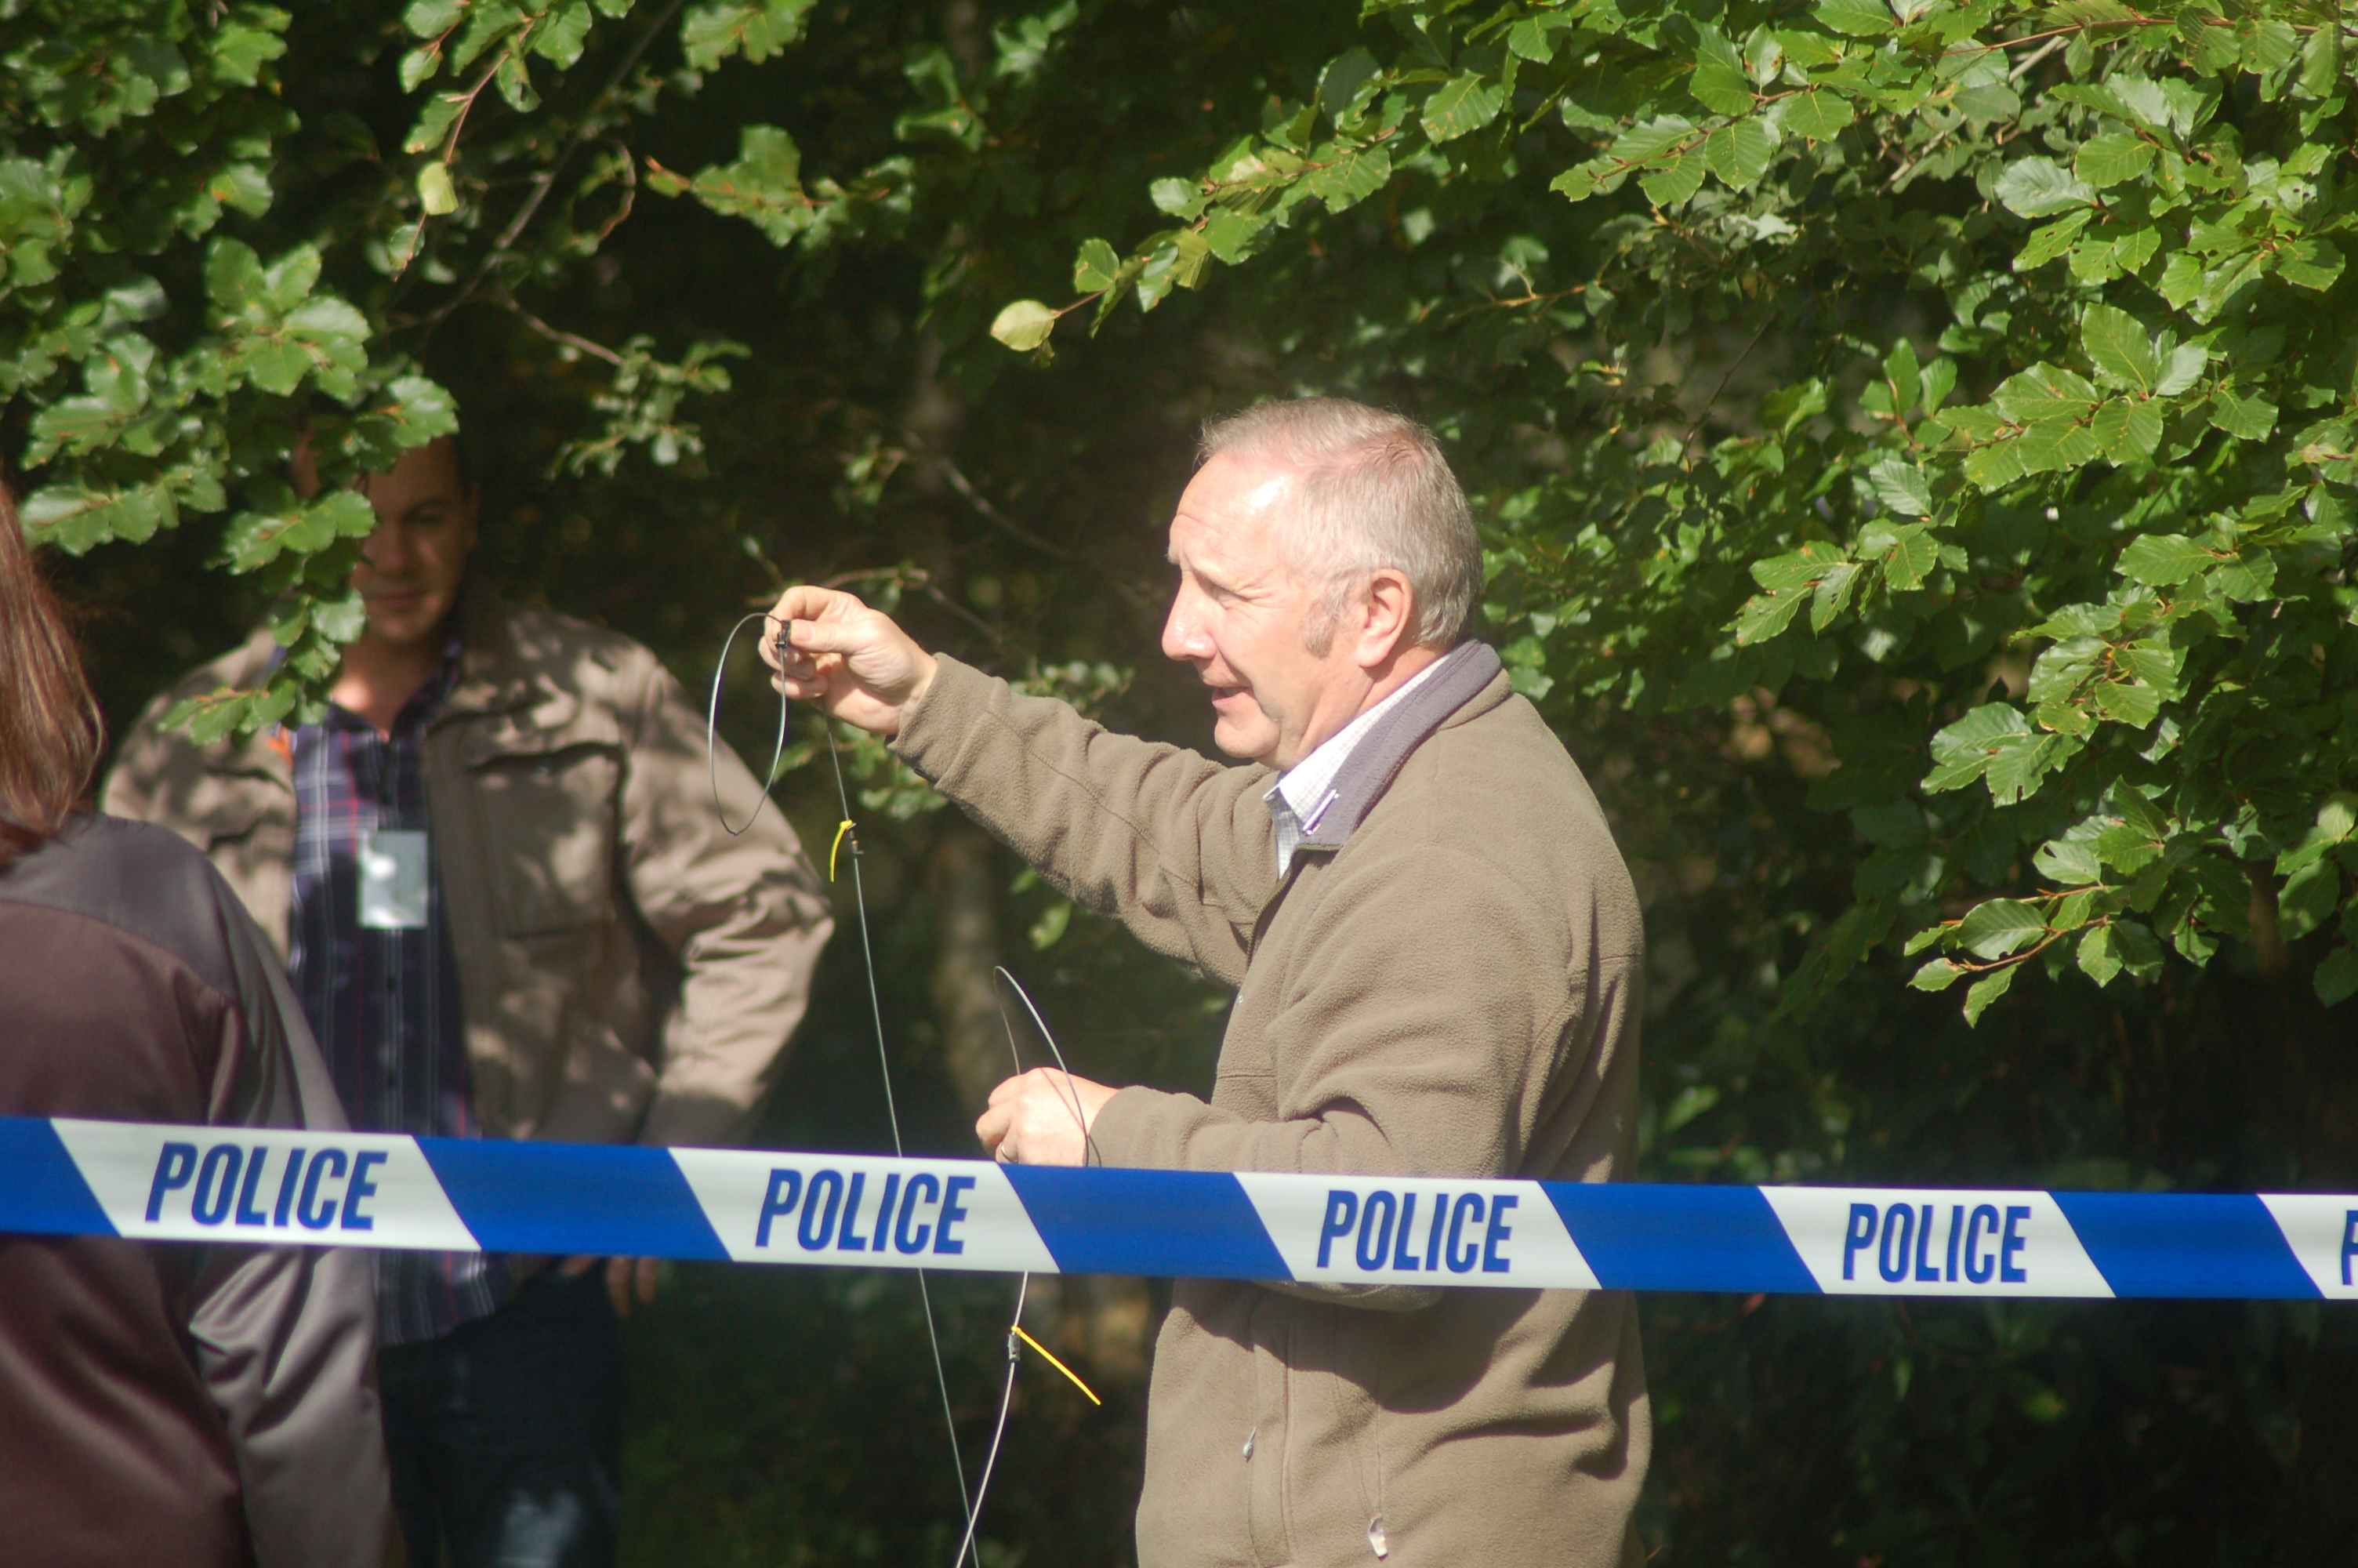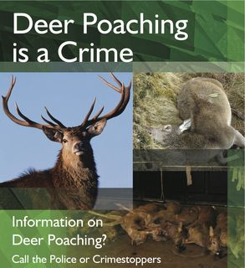

Since its concept in 1997 this national course has grown from strength to strength, and achieved a landmark in 2014, having reached 1000 staff trained. A fantastic achievement which could not have been possible without the full support of many of the valuable contributions, and support from the partners. The course has continually been reviewed, and has recently undergone a further process to ensure that it achieves its aims, and objectives, and delivers value for money, and keeps in line with current Police training requirements, and delivers on the national priorities. It is open to all staff involved withIn enforcement, and has recently seen many Community support officers, special constables, forensic staff, and other support staff attending.

The course is delivered, and managed by two retired police officers who have over 44 years experience between them, and they are supported by specialists in their fields, and this Is what makes this course such a success. We are keen to ensure that the course is kept to this multi agency style approach, and to oversee that the Partnership for Action Against Wildlife Crime, Conference and Training Group oversee's training, and ensures that it meets current demands.

It is the only course of its kind within the UK currently to achieve such a high level of education during the week long course, and the accreditation through PAW, is recognised now by a number of external organisations, and is seen by several police forces as best practice.

The content includes the NWCU, CITES, Wild Birds, poisoning and pesticides, protected species, bats, badgers, hunting, poaching, traps, Plants, cruel sports, and health and safety issues. It has been run recently out of the Police College Bramshill, but with the sale of that estate, will be moving to a new home, which for 2015 will be Yarnfield Conference Centre, Staffordshire.

Costs are kept to a minimum but there is the need to charge for the course, to meet accommodation, meals, classrooms, IT, printing, and mileage for some of the guest organisations. We have fought to keep the costs down, and there will be no increase again for 2015. Course dates for the courses are on the booking form at the end of this document.

**The course cost for 2016 is £750-00, which includes accommodation.**

# Full multi-agency training provision

An essential feature of wildlife law enforcement is a multi-agency partnership approach. This is being fully reflected in the course with the support and participation of many Governmental and non Governmental organisations. Representatives of UKBA, JNCC, DEFRA, RSPCA and RSPB, BCT, LACS, NE to name but a few, are amongst those who have either provided advice or will be present during the course.

## Health and Safety focus

As Police Forces take on Health and Safety legislation the course addresses the needs of WCO's. The requirements of Risk Assessing, and techniques to minimise risks from the many hazards confronting the WCO will be a strong feature of the course.

**Course Aim**

**The aim of the course is therefore:-**

"To equip Officers with the ability to undertake investigations

in a safe and efficient manner within a multi-agency framework where appropriate".

Course Curriculum

* **Health and Safety at Work**

Consider Risk Assessments, risks and preventative measures.

* **National Intelligence Model and the work of NWCU.** 
  + - * + **Natural England – the Wildlife Incident Investigation Scheme (WIIS)** Investigating cases of suspected pesticide poisoning of wildlife and companion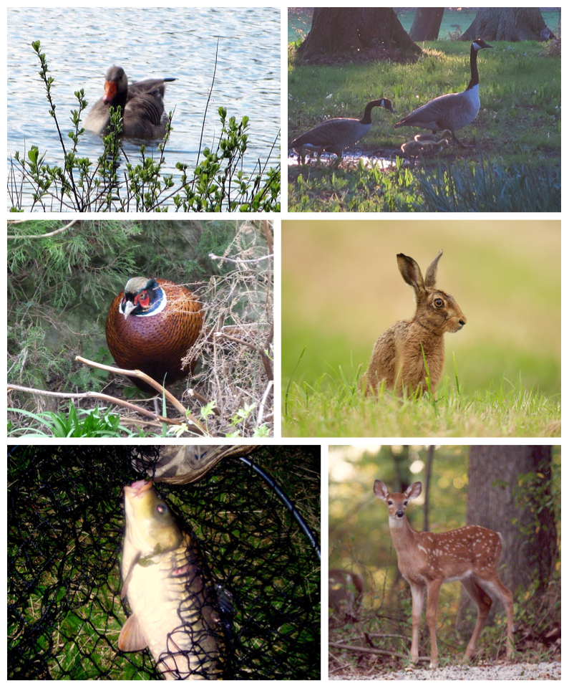 animals**.**

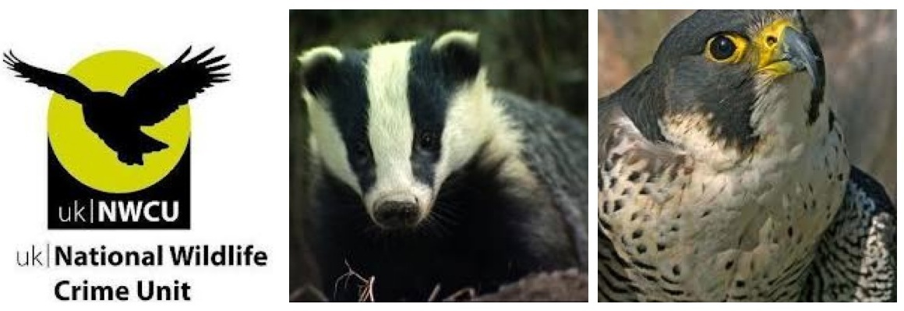

* **COTES Regulations**

The Convention on International Trade in Endangered Species.

COTES Regulations.

Identification of controlled specimens of fauna and flora.

Recognition and uses of derivatives.

Practical law enforcement. The work of UK Border Agency.

* **RSPB Case Investigation and Birds, and Habitat Protection.**

Offences against birds

Evidence and intelligence gathering;

Lawful and unlawful activities relating to birds

* **Bats and the Law**

Development and constructions issues

* **Land and Water Management**

Lawful and unlawful activities relating to game, deer and fish.

* **The RSPCA, SOU and Cruel Sports**

Organised persecution of animals and animal welfare.

* **Badgers and the Law.**

Badger baiting and cruelty

* **Amphibians and Reptiles.**
* **Hunting Act.**
* **Non-Native species.**
* **Plants and the Law.**

The course is not be restricted to existing full or part time Force WCO's but is open to any serving Police Officer irrespective of rank who has a need for a basic understanding of the wildlife enforcement arena. Police Community Support Officers and Special Constables along with Police Staff are welcome. No previous experience is required.

It has also been decided to open the course to non-police staff who have an active role in enforcement of the UK laws that protect our flora and fauna and open spaces.

For further details please contact either:

Craig Fellowes Wildlife Training Consultancy.

Mobile 07540532303

E-mail craig@wildlifetraining.co.uk

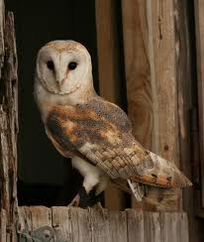





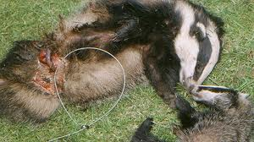

# *The National Police Wildlife Crime Officers Foundation Training Course Booking Form*

***Weeks beginning;***

***April 25th to 29th 2016, or Sept 26th to 30th 2016.***

**Applicant**

|  |  |  |  |
| --- | --- | --- | --- |
| Surname | Forename | Rank/Collar No./Title | Force |
|  |  |  |  |

|  |  |
| --- | --- |
| Full Address | Invoice Address |

|  |  |
| --- | --- |
| Telephone No. | Email Address: |
| Email address for officer attending: | **PURCHASE ORDER No :** |

|  |  |
| --- | --- |
| Supervisors approval confirming availability Print Name: | Telephone No.  Ext. |
| Signature: |  |

## Will you require accommodation ?

|  |
| --- |
| Personal Requirements (e.g. Dietary, or any relating to physical disability) |
|  |

Applicants Signature

Please reply promptly. In the first instance send a copy of the booking form completed via email to

Craig@wildlifetrainng.co.uk.

Places are restricted to the first 20 applicants.

**For any enquires please contact Craig Fellowes 07540532303**

**NATIONALLY AGREED POLICY**

If you cancel your reservation for the course during the 3 month period preceding the course, due to the fact that your force cannot fulfil its obligation, then a course administration fee of 10% may be levied.

Cancellation by you within 39-20 working days – 25%, 19-10 days – 50%, 9 working days- 100%.

*If it is found that the course is under-subscribed, the trainers have authority to cancel the course.*